Talha Khan
IT-481-DL1
3/23/2026

Assignment: Lab 8 – Protecting data in transit using HTTPS

Step 1: In the AWS console search bar, I typed EC2 and clicked on EC2 Virtual Servers in the cloud. 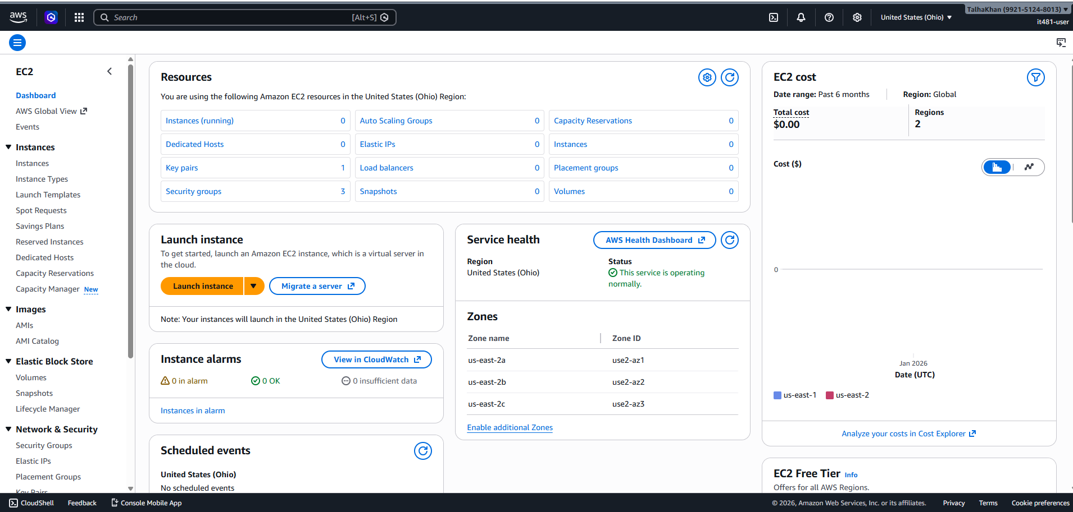

Step 2: Next, I clicked on “Launch Instance” and configured the instance:
- Name: it481-lab8
- AMI: Amazon Linux 2023 (Free tier eligible) 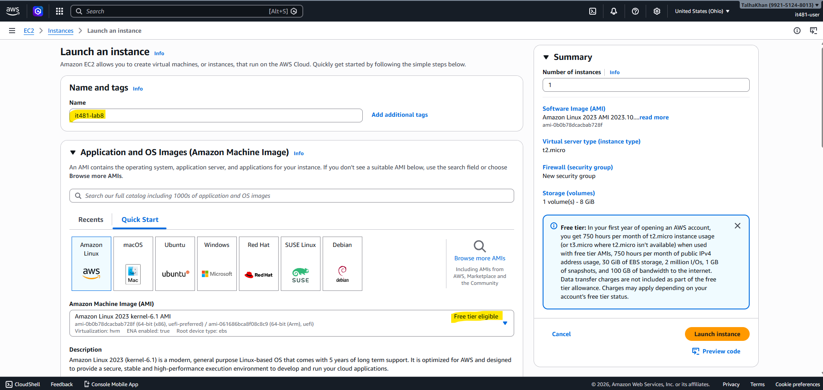
- Instance Type: t2.micro (free eligible)
- Key Pair: lab8-key (Created New) 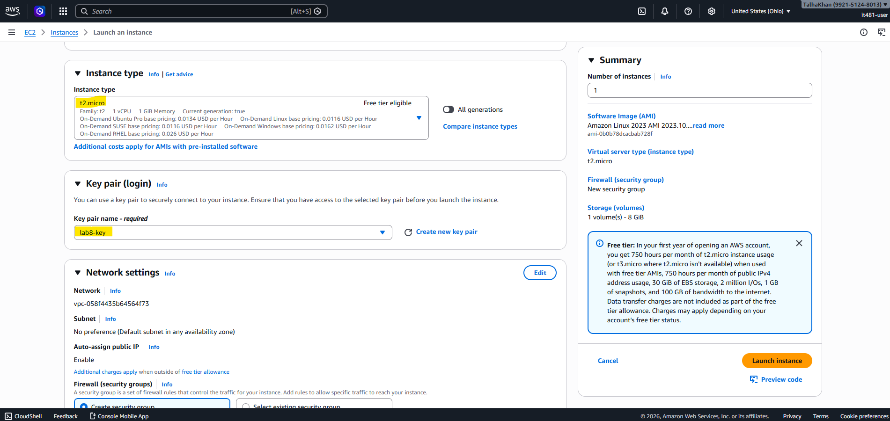
- VPC: Default VPC
- Subnet: Default Subnet
- Auto-assign public IP: Enabled 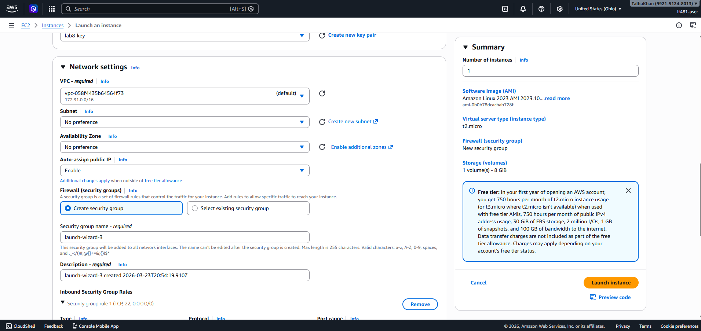
- Under Network settings, I added the following rules:
- SSH (22); Source: 0.0.0.0/0
- HTTP 980); Source: 0.0.0.0/0
- HTTPS 9443); Source: 0.0.0.0/0
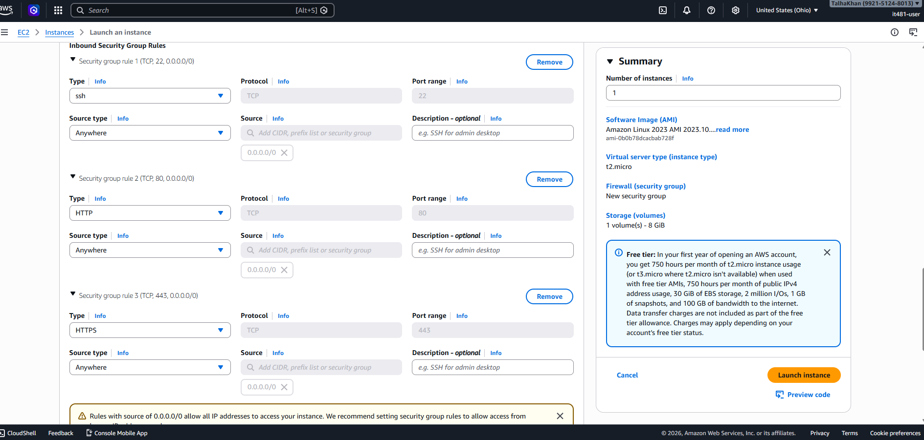
- Launched instance: 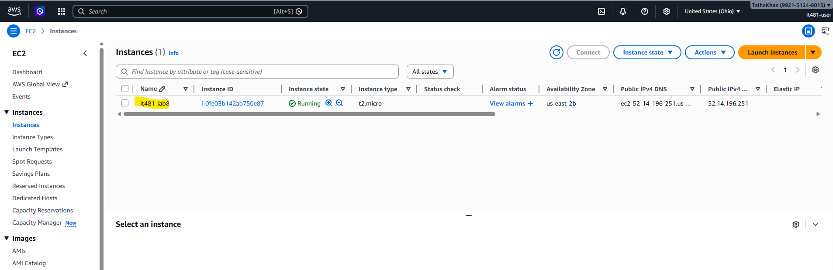
Step 3: Once the instance was running, I connected using SSH and entered the following commands:
Sudo dnf update -y
Sudo dnf install -y httpd mod_ssl openssl
Sudo systemctl start httpd
Sudo systemctl enable httpd

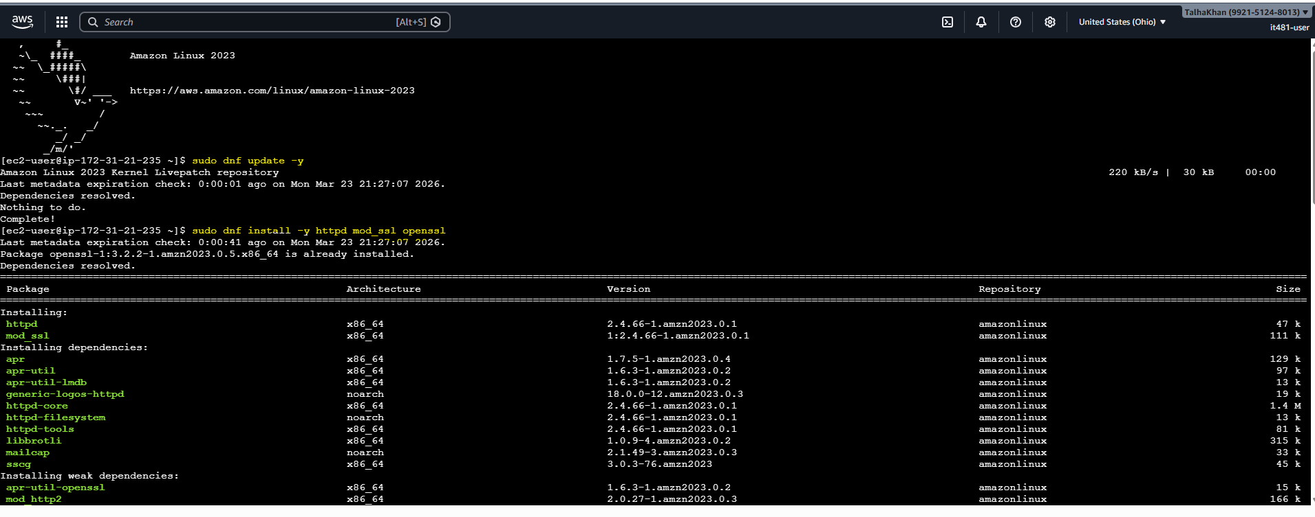
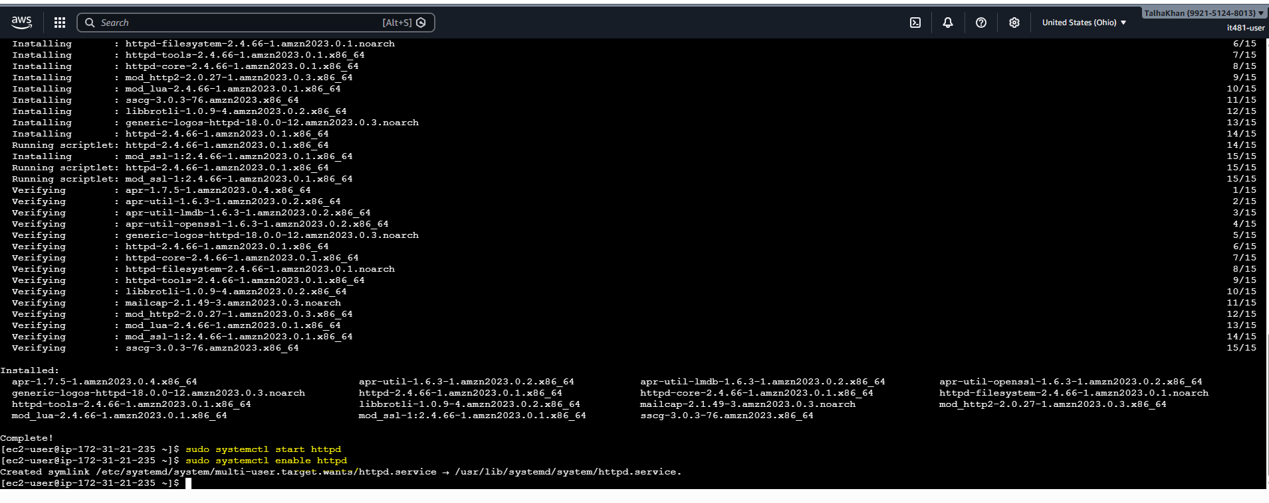
Echo “<h1>IT 481 Lab 8 – HTTP Website</h1>” | sudo tee /var/www/html/index.html 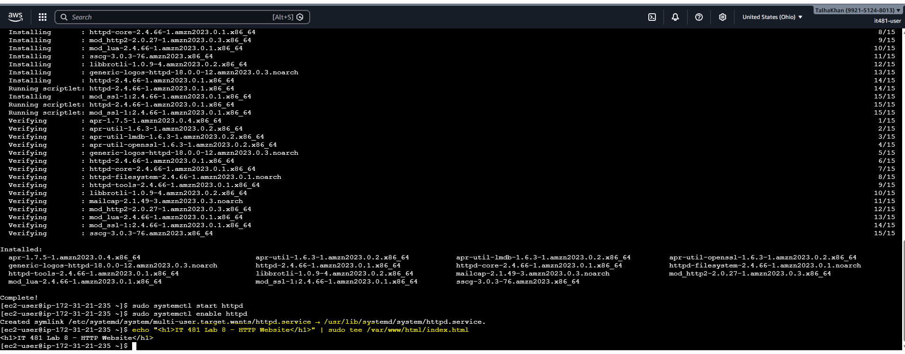
Step 4: Next, I went to http://<EC2-public-Ip> and verified that the page loads successfully. 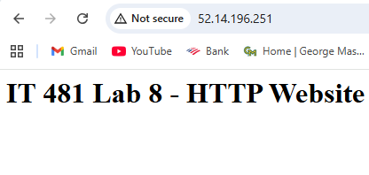
Step 5: Now, I entered the following commands:
Sudo openssl req -x509 -nodes -days 365 -newkey rsa:2048 \ -keyout /etc/pki/tls/private/it481.key \ -out /etc/pki/tls/certs/it481.crt 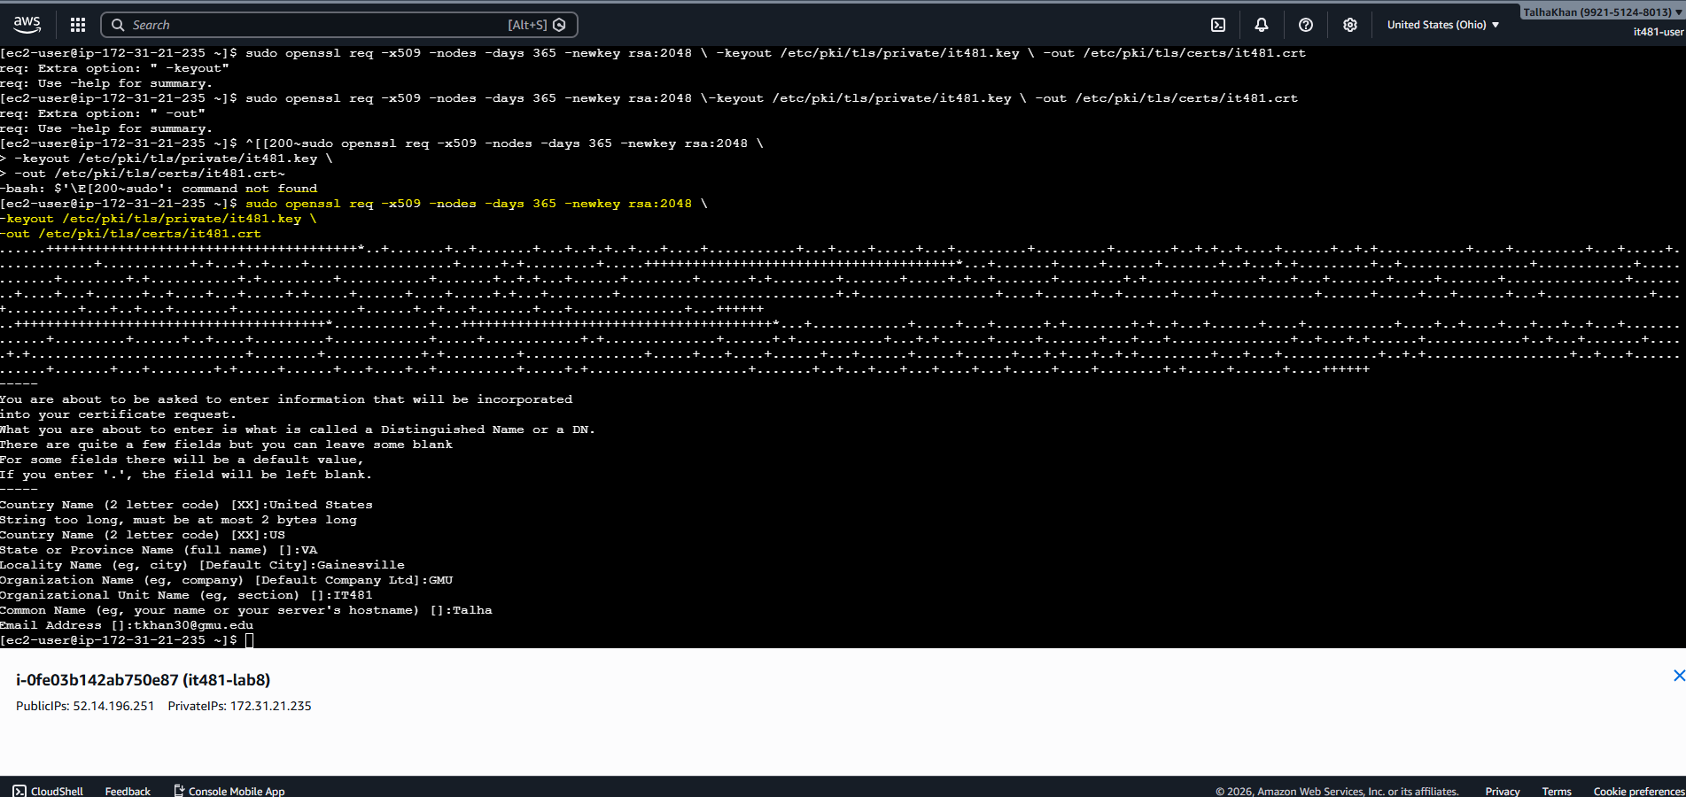
Sudo nano /etc/httpd/conf.d/ssl.conf
I made sure these lines were in the document:
SSLCertificateFile /etc/pki/tls/certs/it481.crt
SSLCertificateKeyFile /etc/pki/tls/private/it481.key 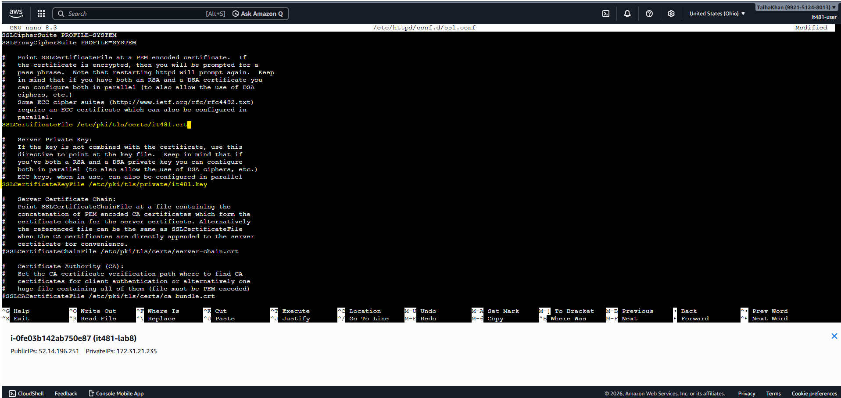
Sudo systemctl restart httpd 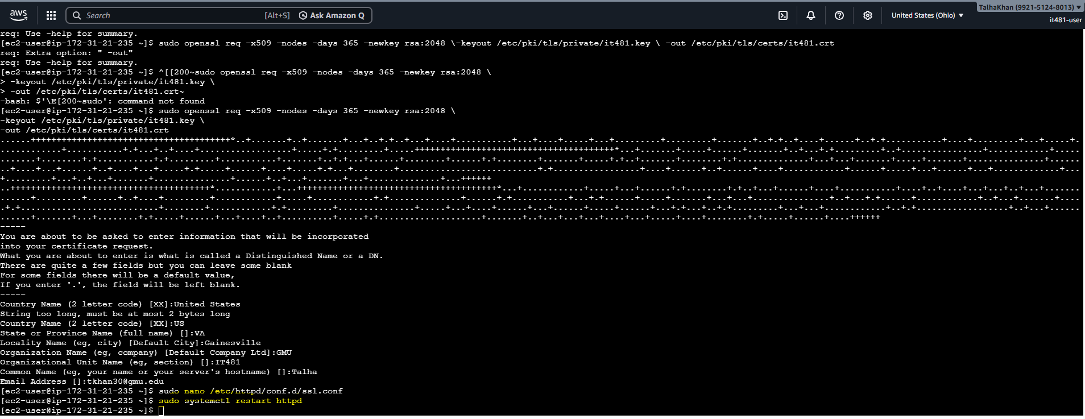
Step 6: Next, I went to https://<EC2-public-Ip> and verified the website is loading. 